# Software User’s Manual



## Installation Guide

### Prerequisites

Before we install the application and throw it into operation, the preconditions about the environment and tools specified below must be satisfied.

Firstly, system requirements for the DMSapplication to run on top of are specified below:

* Personal computers for the minimum configuration: 2 Gb of RAM, 50Gb of hard disk, Core 2 Duo 2.0 Ghz;
* Microsoft Windows 7 or higher.
* At least 100MB for the application resources and another 100MB for data storage.

Secondly, these tools must be installed in advance and run without errors:

* IIS Express 7.0 or higher
* SQL Server 2008 or higher,
* .NET Framework 4.5,
* WebDeploy 3.5

### Installation procedures

**Step** 1. Prepare the deployment package

Firstly, you need to publish your application and you’ll get folder to add to IIS

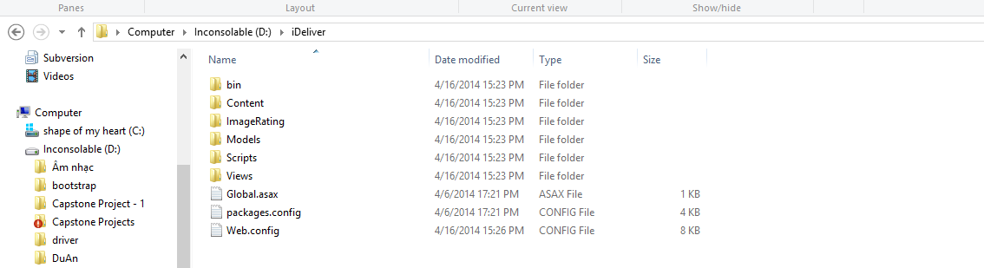

Figure . DMS web application release folder

**Step** 2. **Create the database**

Open the file “DMS.sql” in the folder “Document” of the deployment package by Microsoft SQL Server Management Studio (MSSQL).

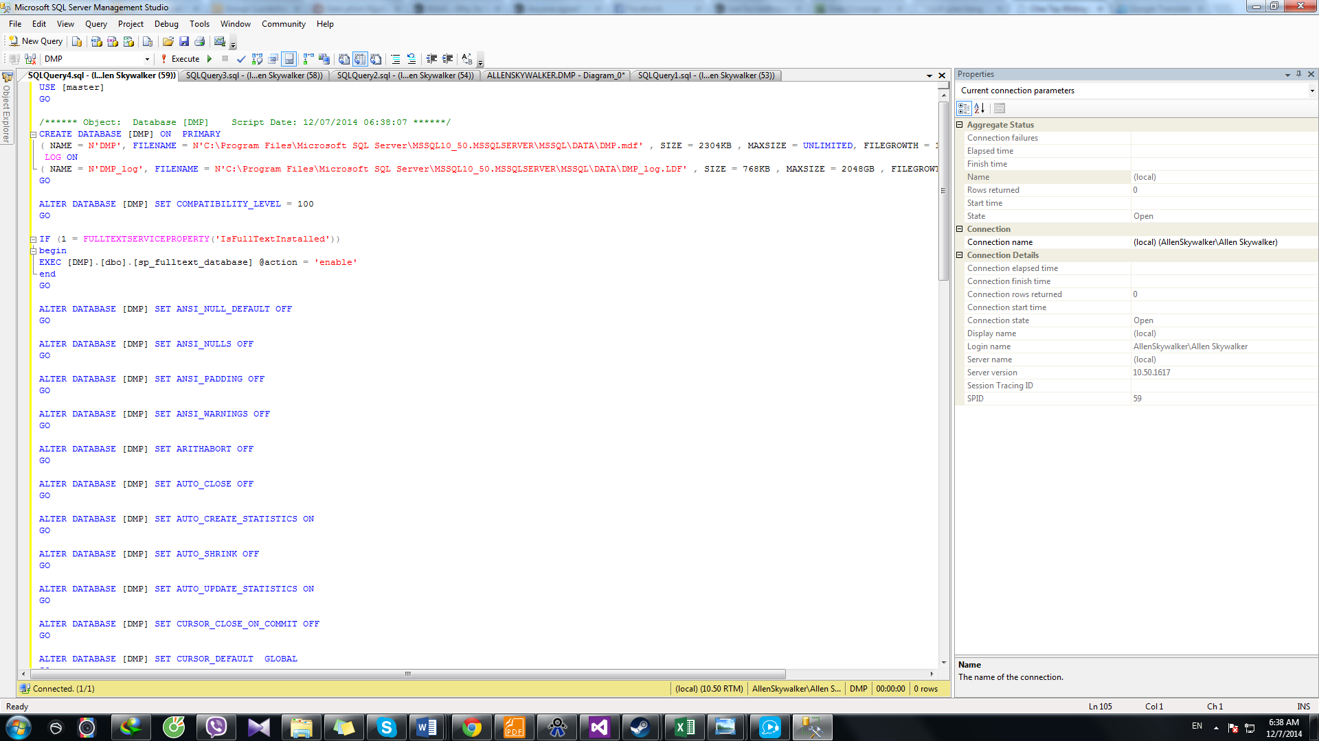

Figure . Create DMSdatabase using SQL Query

**Step 3. Install the application**

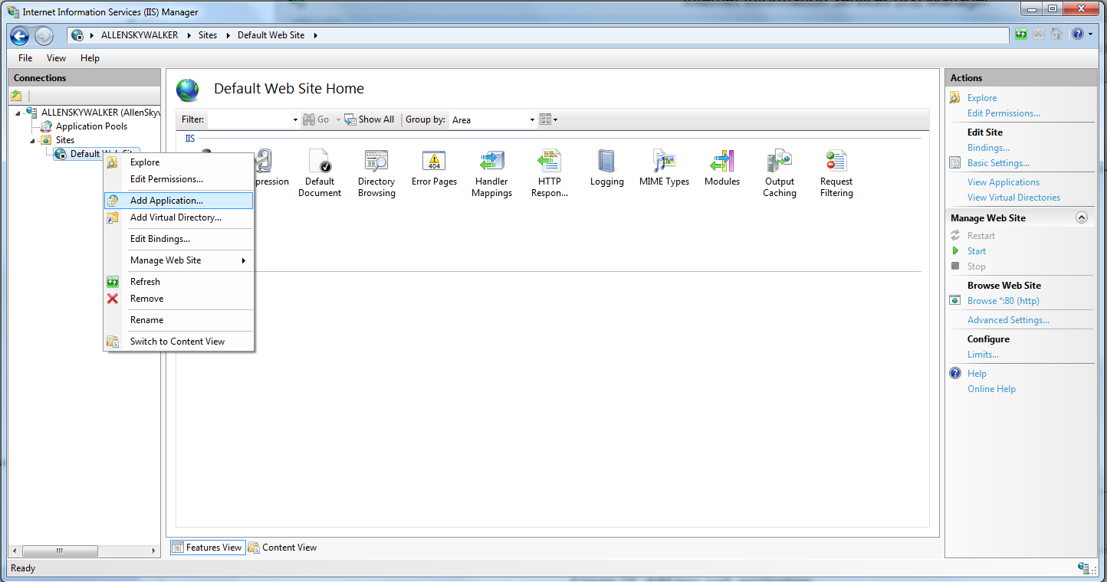

Figure . Add new web application

Expand the Sites folder and then right click on Default Web Site. Select “Add Application…” to open Add Application window. In the “Add application” window, fill the field “Alias” with the name of the website.

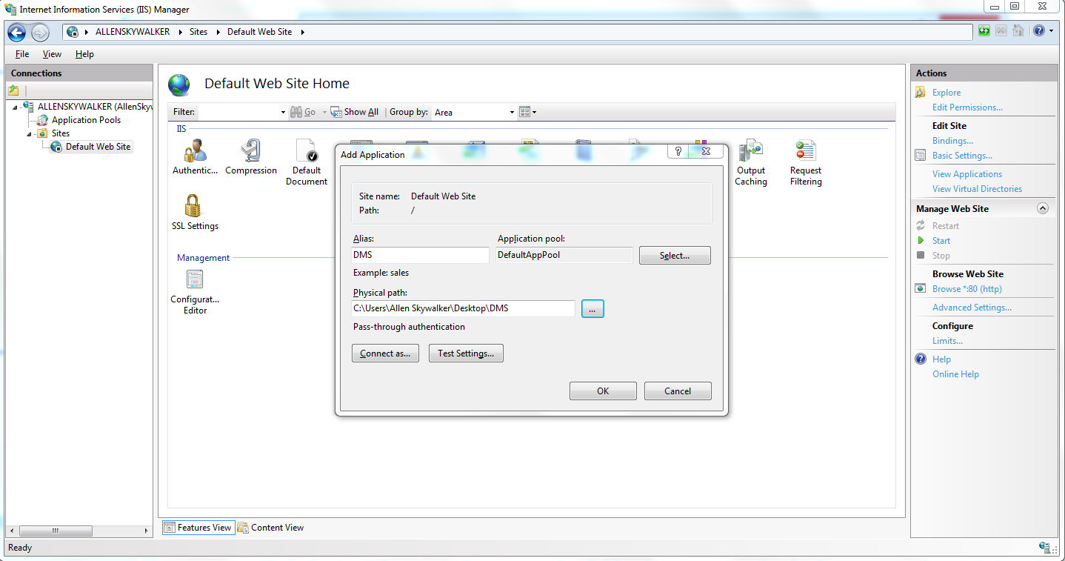

Click the “…” button to browse to the folder that contains the deployment package. Select the “Website” folder in the “DMS” folder, in the “Application” folder and click OK.

Verify that the DMS Website has been added to “Default Web Site” of IIS Express by right-clicking the website’s name, choosing “Manage Application” and then “Browse”.

**Step 4. Configure database connection string**

Folder of the deployment package, find and open the file Web.config using Notepad or any other text editor.

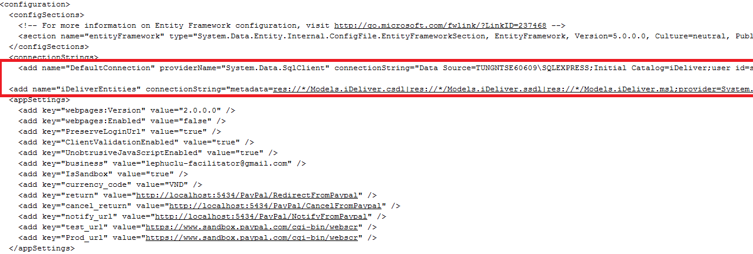

Figure . Configure database connection string

In the connectionStrings tag, change the Data Source of the connection strings to the SQLServer instance where you installed the database. Also, update the password to access the SQLServer instance in the connection strings.

Now go to **http://localhost/aspnet_client/DMS** and enjoy the website**.**

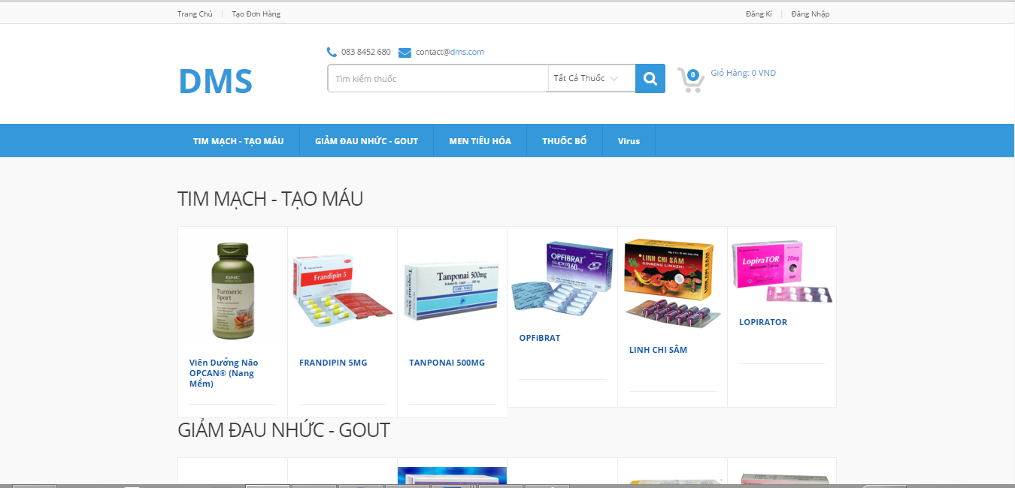

Figure . Run DMSwebsite

## User’s Guide



### Guides for Customer



#### Log in to the system

This function allows a user with a registered account to log in to the DMSsystem.

1

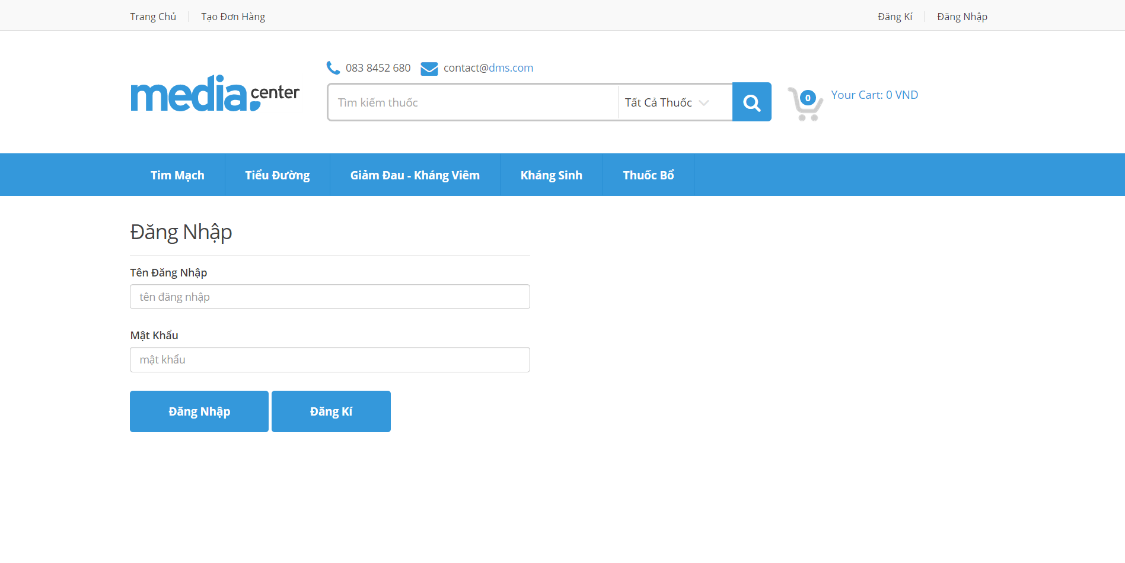

3

4

4

2

Screen . Login screen

|  |  |
| --- | --- |
| Step | Instruction |
| 1. | Click the “Đăng nhập” button on the menu bar of the “Trang chủ” page. |
| 2. | Fill the registered account in the “Tên đăng nhập” field |
| 3. | Fill the password in the “Mật khẩu” field |
| 4. | Click the “Đăng nhập” button to log in to the system. You will be redirected to the page you are viewing |

#### Log out of the system

This function allows the user to log out of the system after he or she finishes browsing the website.

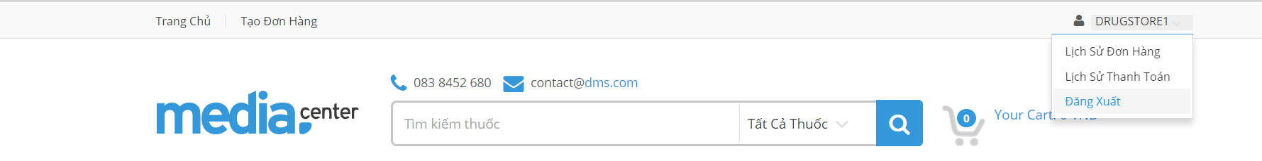

1

Screen . Logout screen

|  |  |
| --- | --- |
| Step | Instruction |
| 1. | Click the “Đăng xuất” link on top right of page you are viewing. You will be redirected to the page you are viewing if this page allows guests to access or the “Trang chủ” page otherwise. |

#### Register an account with Customer role

This function allows the user to register a new account with Customer role in the DMSsystem.

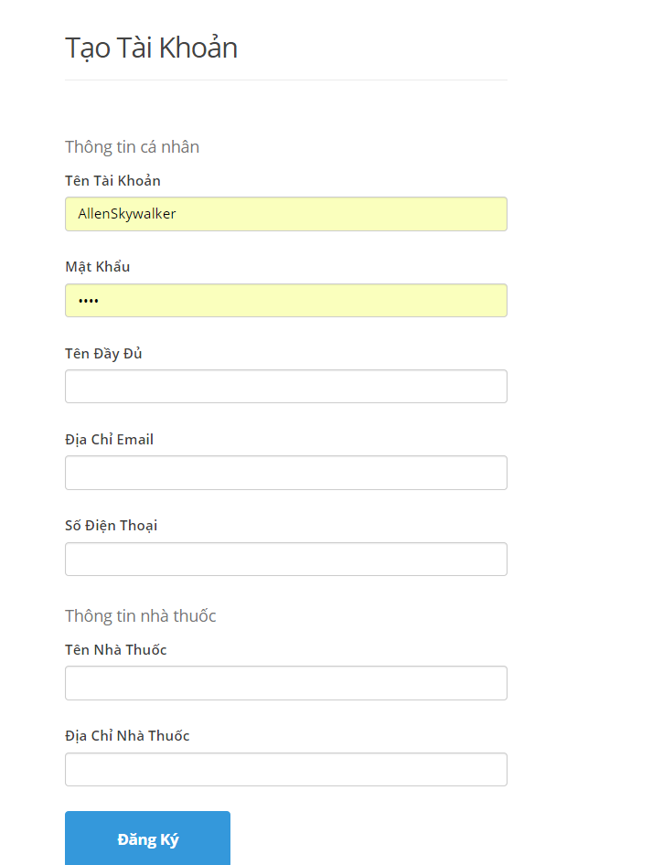

2

1

Screen . Register screen

|  |  |
| --- | --- |
| Step | Instruction |
| 1. | Fill in the fields “Tên đăng nhập”, “Mật khẩu”, “Email” “Điện thoại” with your username, password, email address, phone number.  Your input will be validated as you type. Please make sure that all the values that you provide are validated. |
| 5. | Click the button “Đăng ký” to proceed to register your account with Customer role. |

#### Make order

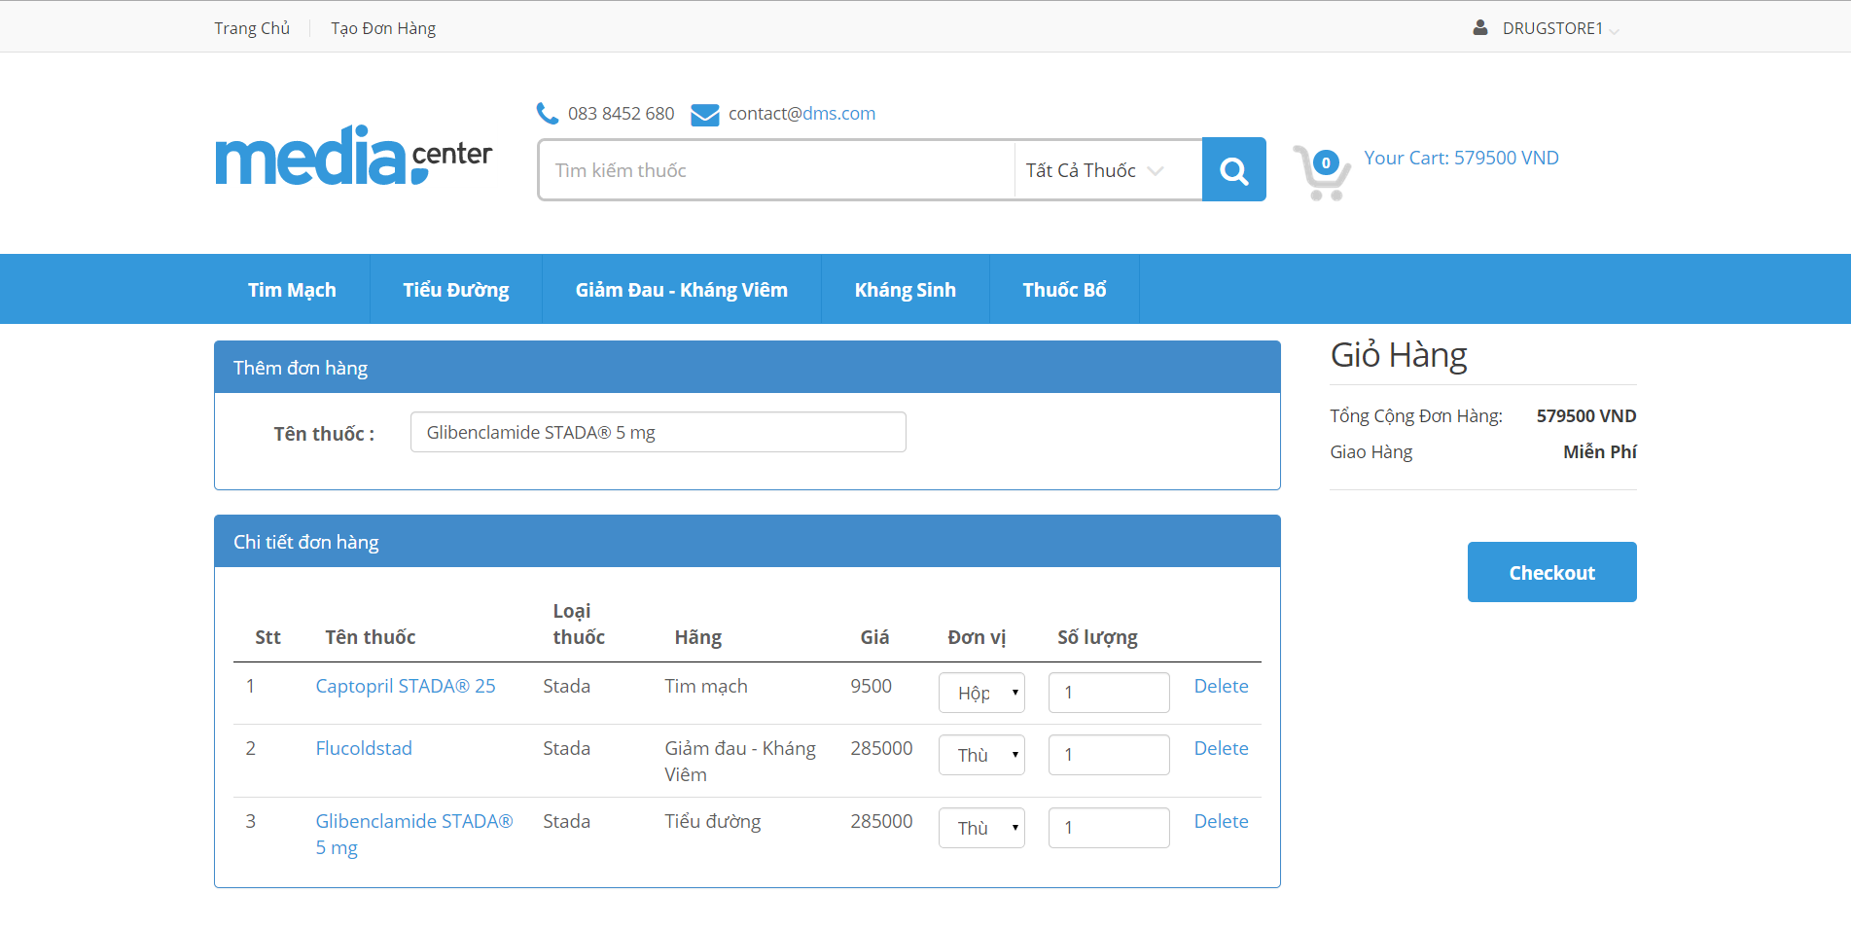

4

3

2

1

2

Screen 4. Cart screen

|  |  |
| --- | --- |
| Step | Instruction |
| 1. | Click cart icon to go to Cart screen |
| 2. | Input name of drug which want to order |
| 3. | Choose unit of drug |
| 4. | Choose quantity of drug |
| 5. | Click the button “Checkout” to proceed to make order |

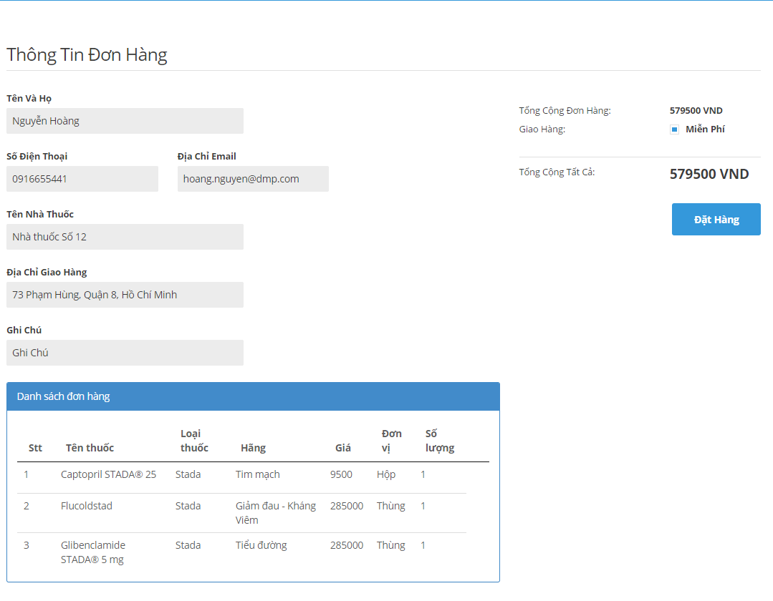

2

1

Screen 5. Order screen

|  |  |
| --- | --- |
| Step | Instruction |
| 1. | Fill information |
| 2. | Click “Đặt hàng” button to make order |

#### View order history

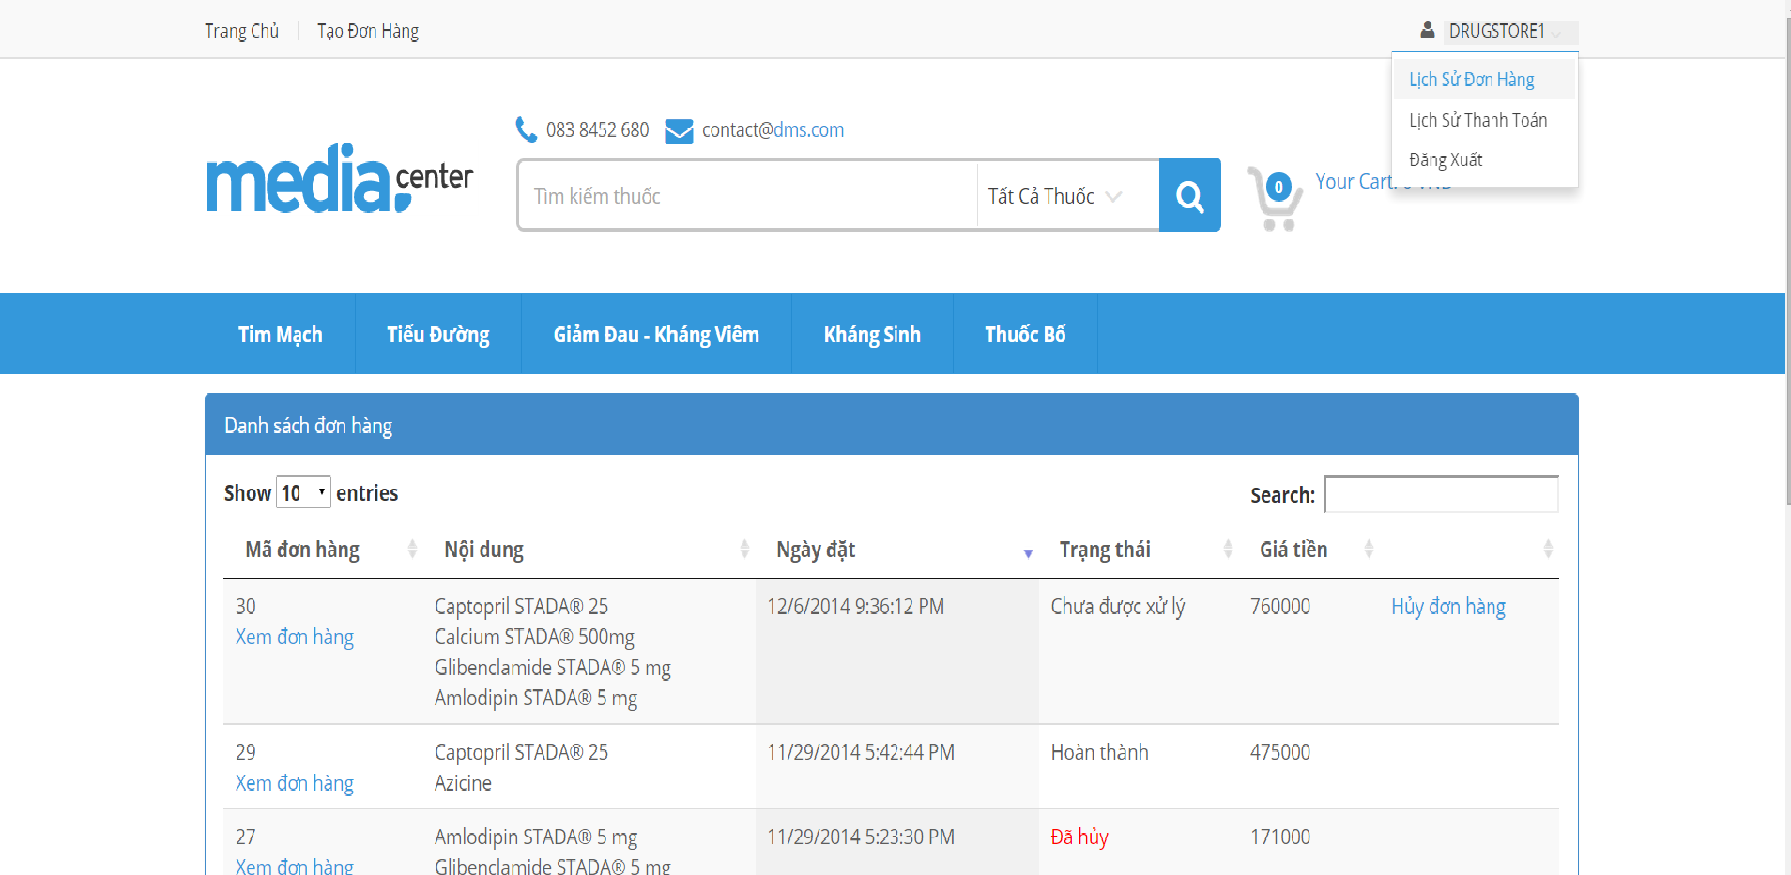

1

Screen 4. Order History screen

|  |  |
| --- | --- |
| Step | Instruction |
| 1. | Click on usernam on menu bar. |
| 2. | Click “Lịch sử đơn hàng” link to see order history |

#### View payment history

1

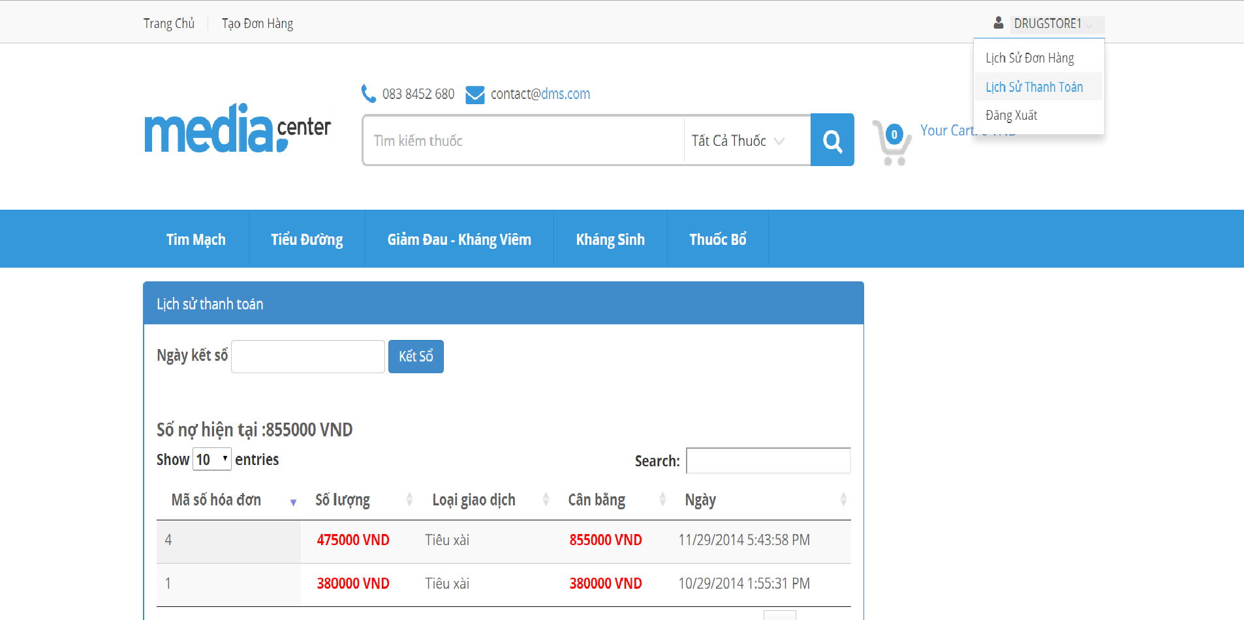

3

Screen 4. Payment History screen

|  |  |
| --- | --- |
| Step | Instruction |
| 1. | Click on username on menu bar. |
| 2. | Click “Lịch sử thanh toán” link to see order history |

### Guides for Staff

#### Add drugs

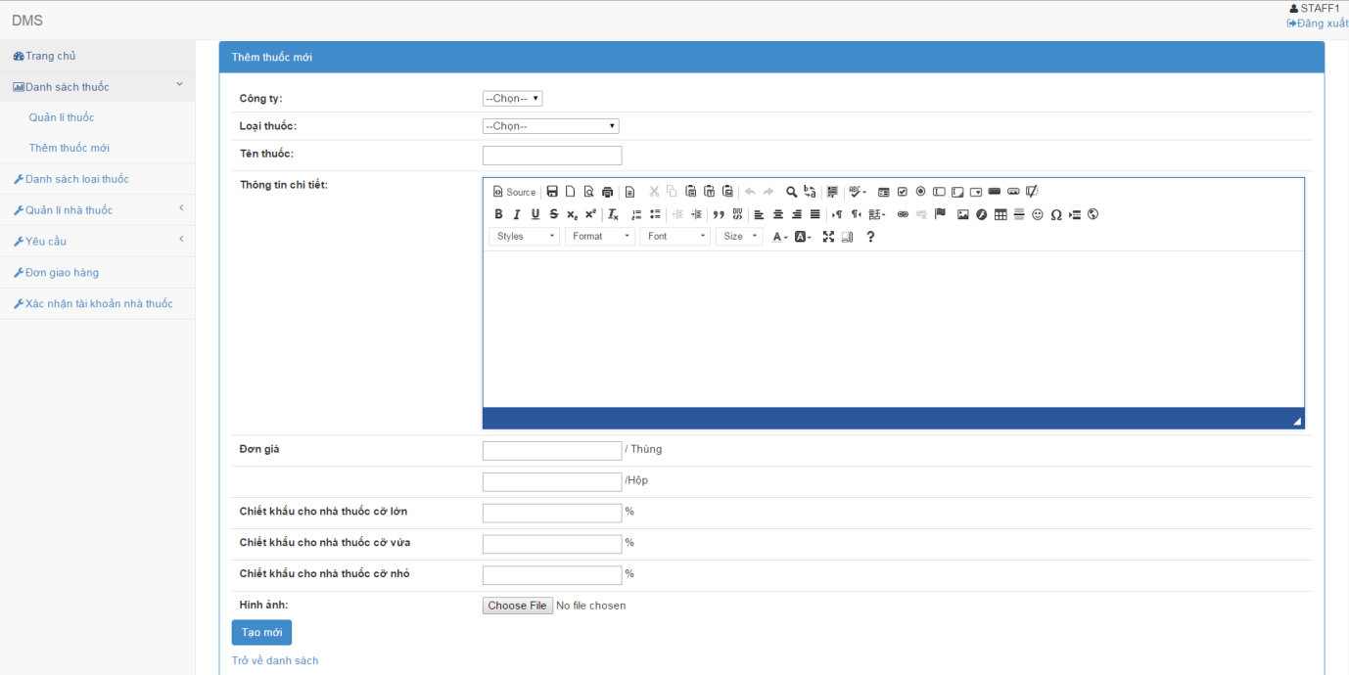

Screen 5. Add drugs screen

|  |  |
| --- | --- |
| Step | Instruction |
| 1. | Click the “Đăng nhập” button on the menu bar of the “Trang chủ” page. |
| 2. | Fill the registered account in the “Tên đăng nhập” field |
| 3. | Fill the password in the “Mật khẩu” field |
| 4. | Click the “Đăng nhập” button to log in to the system. You will be redirected to the page you are viewing |

#### Edit drugs

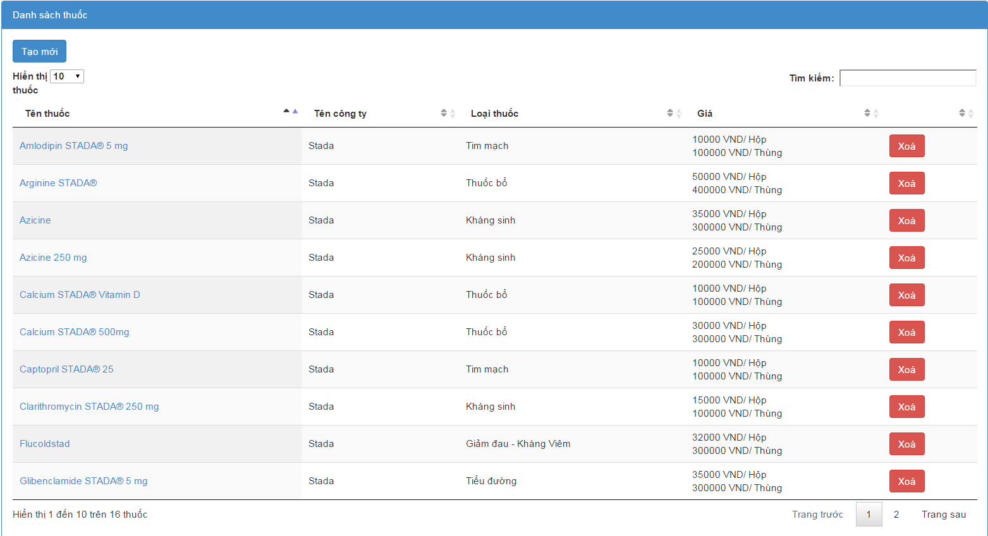 Screen 6. List drugs screen

|  |  |
| --- | --- |
| Step | Instruction |
| 1. | Click on the drugstore name you want to edit |

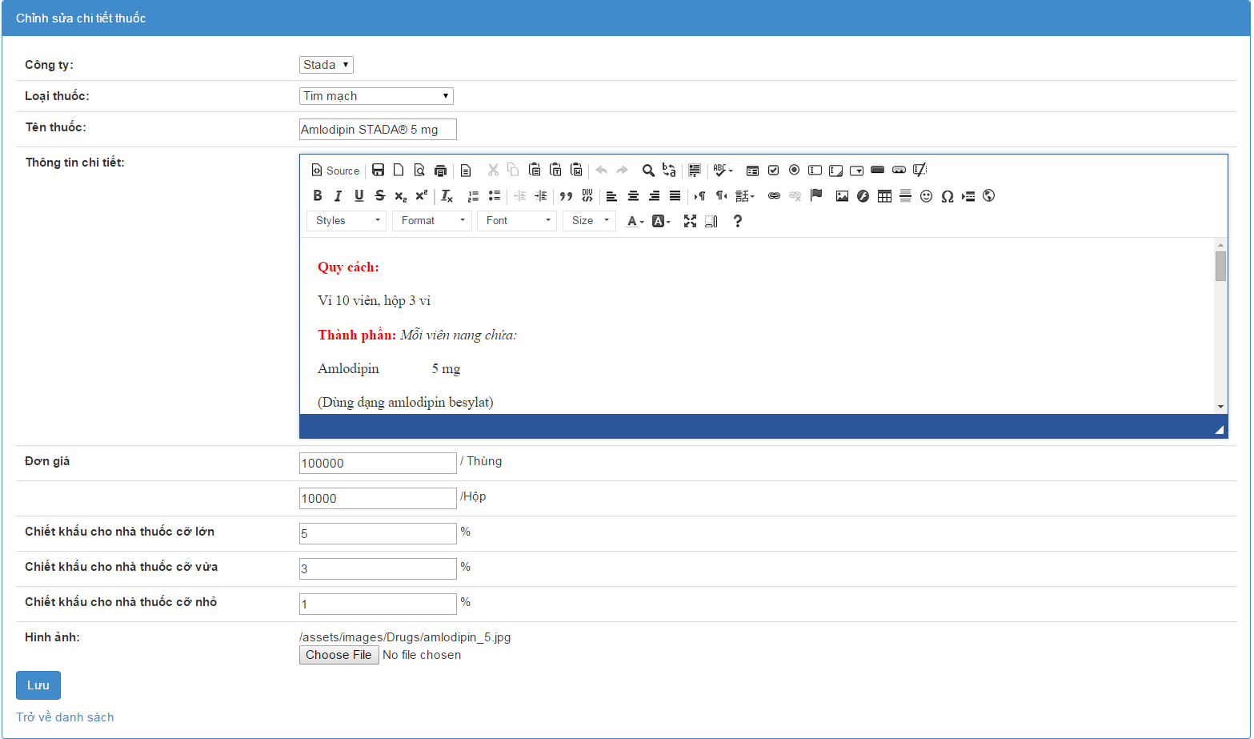

Screen 7. Edit drug screen

|  |  |
| --- | --- |
| Step | Instruction |
| 1. | Edit drug informations |
| 2. | Click “Lưu” button |

#### Delete drugs



Screen 8. List drugs screen

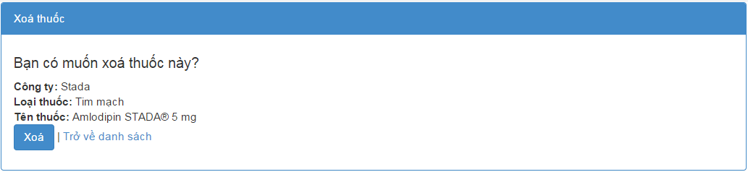

Screen 8. Delete drug screen

|  |  |
| --- | --- |
| Step | Instruction |
| 1. | Click “Xóa” button .Redirect to Delete drug screen |
| 2 | Click “ Xóa” button. |

#### Approve Order

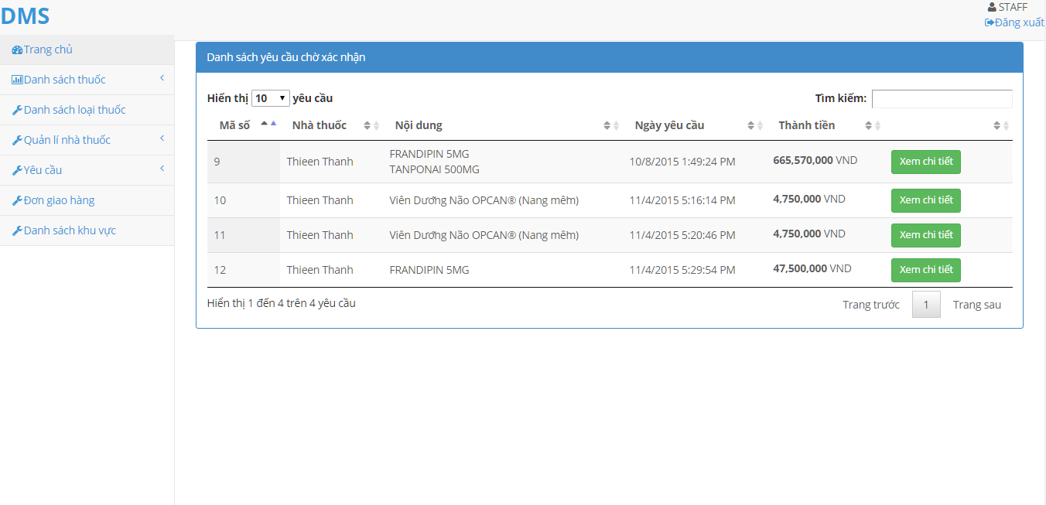

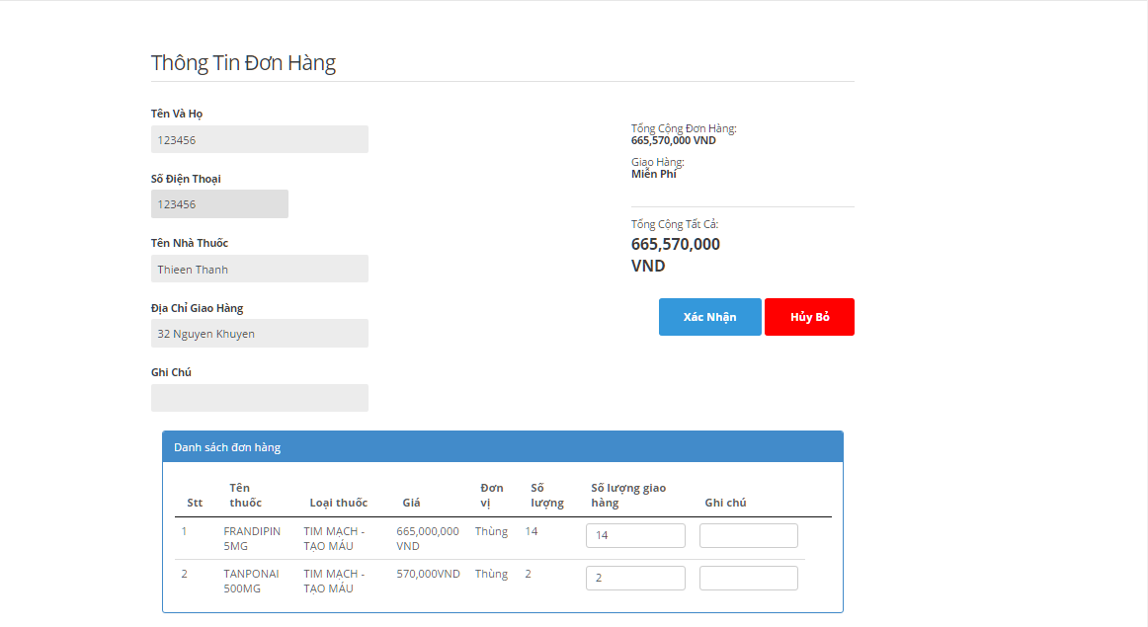

|  |  |
| --- | --- |
| Step | Instruction |
| 1. | Logged in a Staff account, system will show all not yet approve Order |
| 2 | Click “ Xem chi tiết” button, System will show detail of the selected Order |
| 3 | Click “Xác nhận” to approve Order, system will show the screen on step 1  Click “Hủy Bỏ” to cancel Order |

#### Create Delivery Schedule

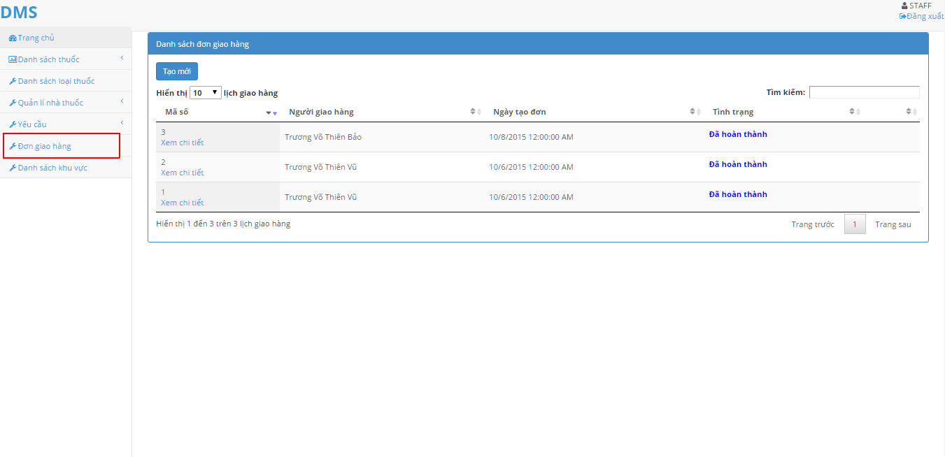

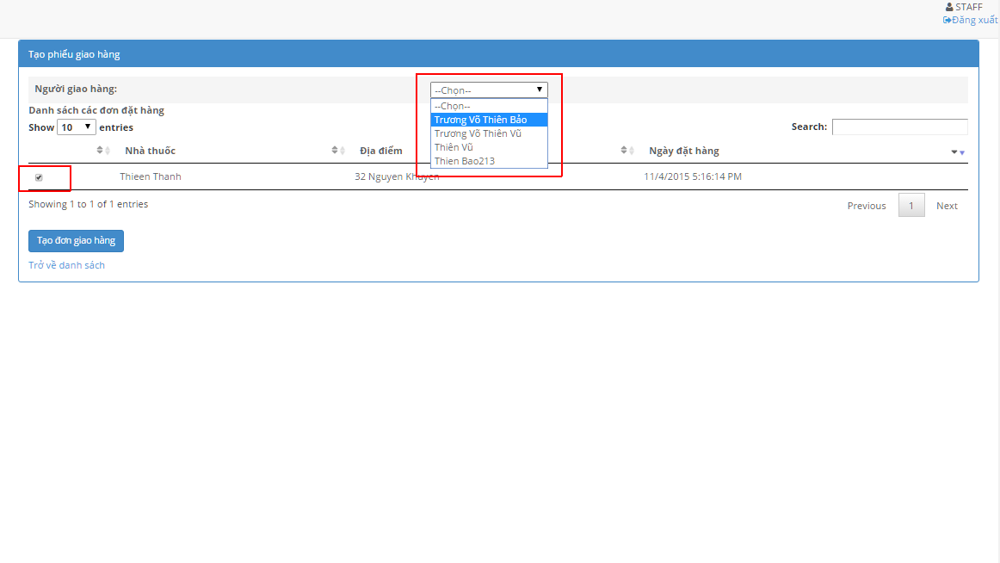

|  |  |
| --- | --- |
| Step | Instruction |
| 1. | On Staff account Homepage, click “Đơn giao hàng” |
| 2 | Click “ Tạo mới” button, System will show all approved Order |
| 3 | Select the Checkbox next to the Order you want to make a delivery schedule  Select Delivery man from the drop-down list |
| 4 | Click “Tạo đơn giao hàng” |

### Guides for Salesman

#### Create order for Drugstore

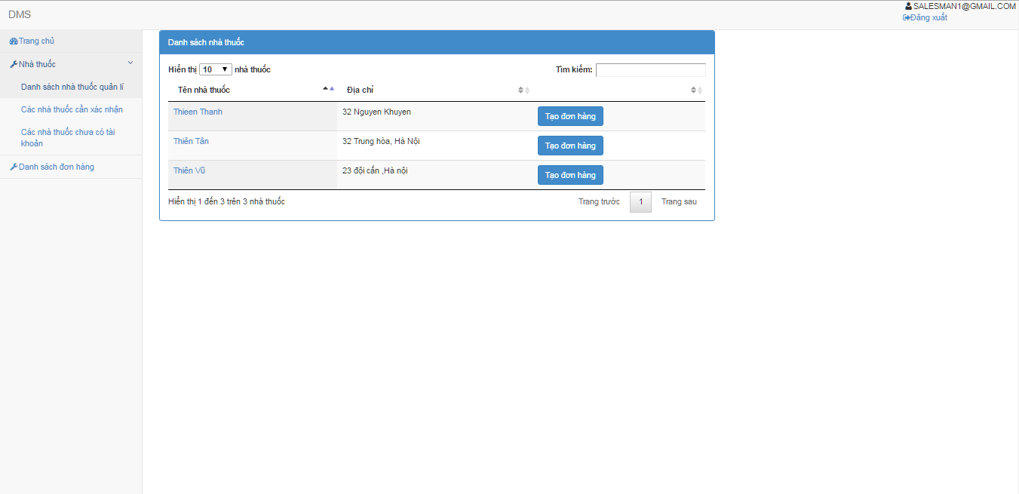

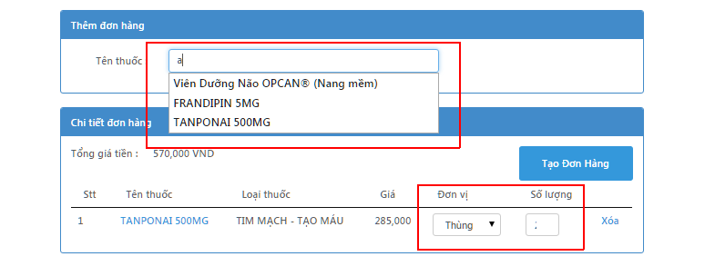

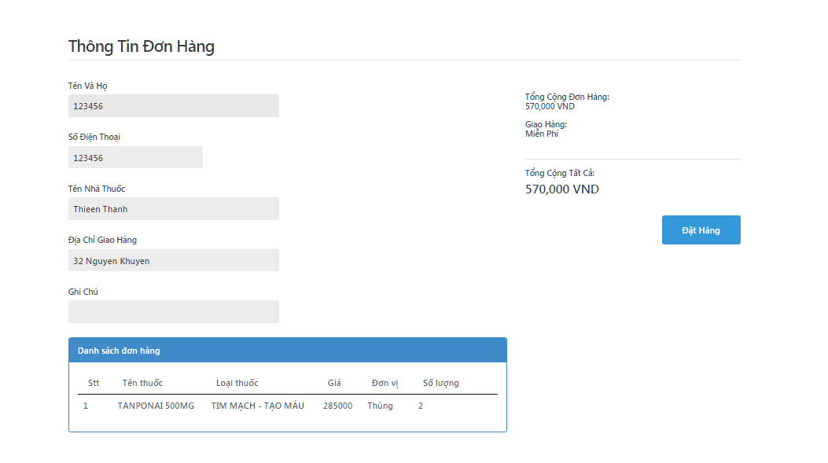

|  |  |
| --- | --- |
| Step | Instruction |
| 1. | After logged in with salesman account, on Salesman account Homepage, click “Nhà thuốc”, then “Danh sách nhà thuốc quản lí” |
| 2 | Click “ Tạo đơn hàng” button , system will show Create Order screen |
| 3 | Enter Drug name in the “Tên thuốc” box to search, then select with mouse  Specified quantity in “Đơn vị” and “Số lượng”  Click “Xóa” to delete selected drug |
| 4 | Click “Tạo đơn hàng”, system will show Order detail screen |
| 5 | Click “Đặt hàng” to complete Order |

#### Verify Drugstore account

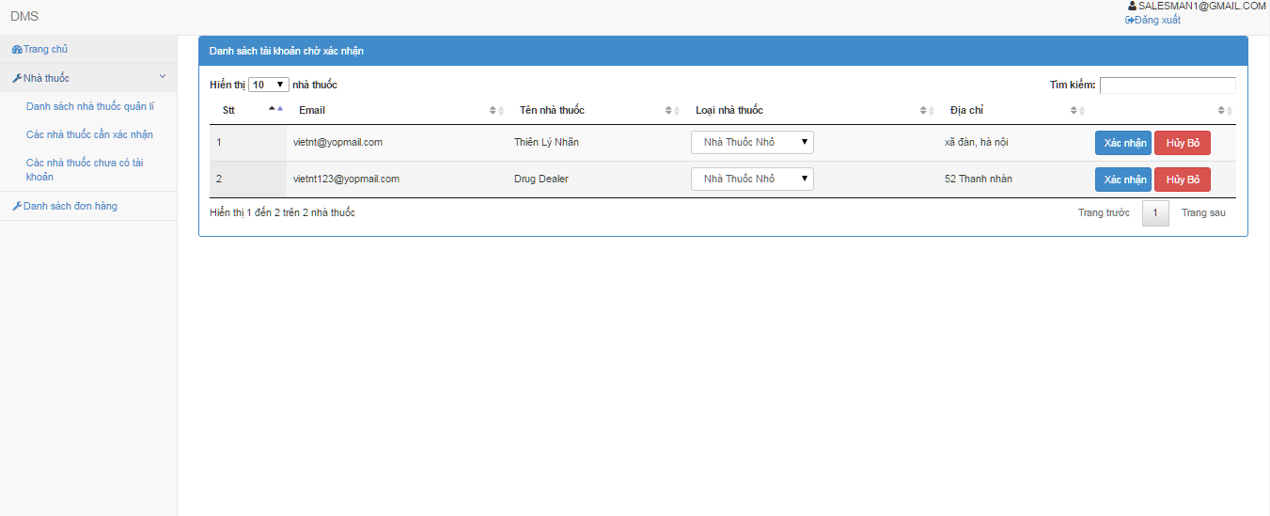

|  |  |
| --- | --- |
| Step | Instruction |
| 1. | After logged in with salesman account, on Salesman account Homepage, click “Nhà thuốc”, then “Các nhà thuốc cần xác nhận”, system will list all not yet verified account. |
| 2 | Specify scale of the store by choose from “Loại nhà thuốc” drop-down list. |
| 3 | Click “Xác nhận” to verify the store  Click “Hủy bỏ” to denied created account |

### Guides for Administrator

After logged in with an Administrator account, system will show Administrator homepage

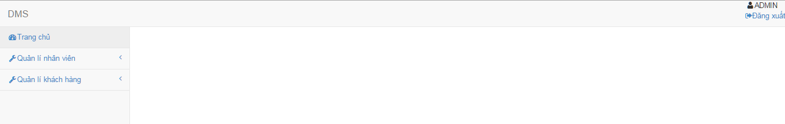

#### Manage Employee

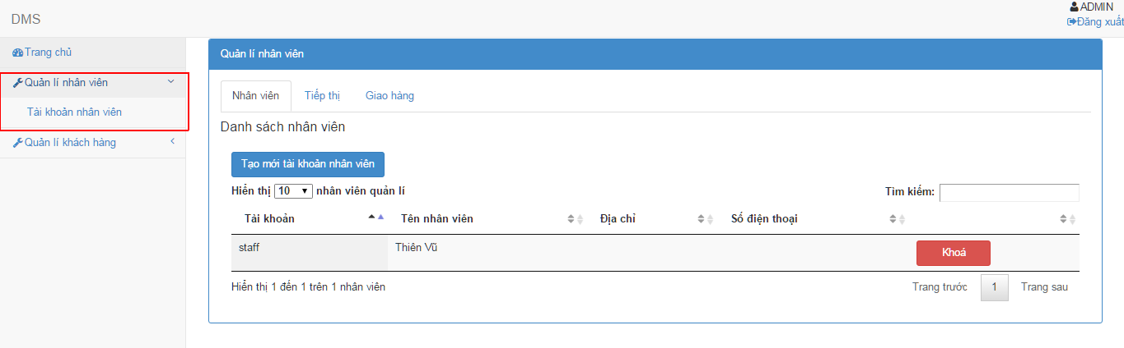

|  |  |
| --- | --- |
| Step | Instruction |
| 1. | On Administrator homepage, Click on “Quản lí nhân viên”, then click “Tài khoản nhân viên” |
| 2 | Click to choose type of account to manage:  For Staff, click “Nhân viên”  For Salesman, click “Tiếp thị”  For Delivery man, click “Giao hàng” |

##### Manage Staff account

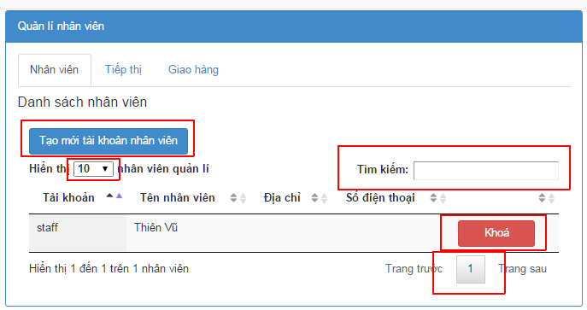

* Create new staff account

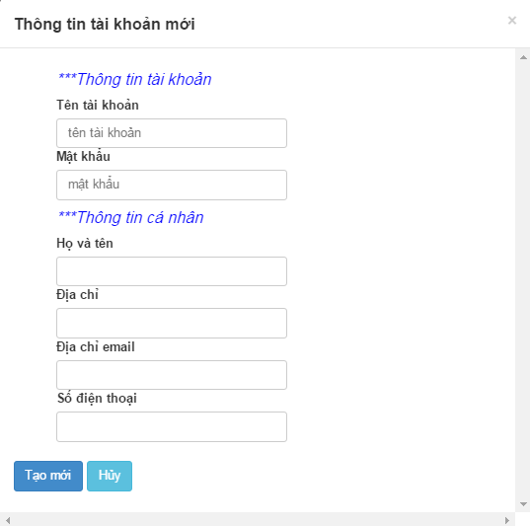

|  |  |
| --- | --- |
| Step | Instruction |
| 1. | Click on “Tạo mới tài khoản nhân viên”, system show Create new staff screen |
| 2 | Fill in the information |
| 3 | Click [Tạo mới] to create new Staff account  Click [Hủy] to return to Staff account management page |

* Search account

|  |  |
| --- | --- |
| Step | Instruction |
| 1. | Type in the text box to search for staff account |

* Lock account

|  |  |
| --- | --- |
| Step | Instruction |
| 1. | Click “Khóa” to lock account |

##### Manage Salesman account

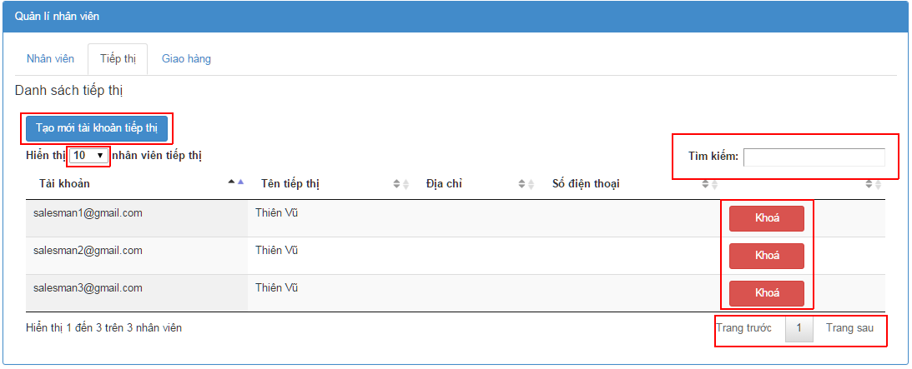

* Create new Salesman account



|  |  |
| --- | --- |
| Step | Instruction |
| 1. | Click on “Tạo mới tài khoản tiếp thị”, system show Create Salesman screen |
| 2 | Fill in the information |
| 3 | Click [Tạo mới] to create new Salesman account  Click [Hủy] to return to Salesman account management page |

* Search account

|  |  |
| --- | --- |
| Step | Instruction |
| 1. | Type in the text box to search for Salesman account |

* Lock account

|  |  |
| --- | --- |
| Step | Instruction |
| 1. | Click “Khóa” to lock account |

##### Manage Delivery man account

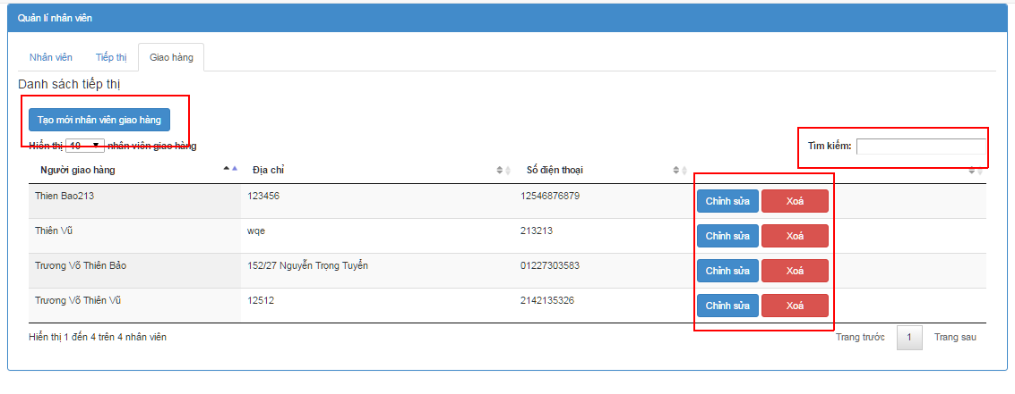

* Create new Delivery man account

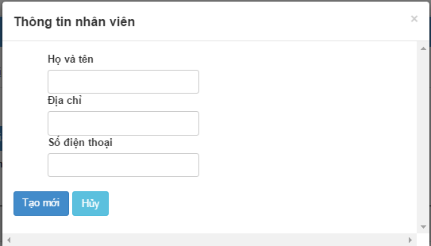

|  |  |
| --- | --- |
| Step | Instruction |
| 1. | Click on “Tạo mới tài khoản tiếp thị”, system show Create new Delivery man screen |
| 2 | Fill in the information |
| 3 | Click [Tạo mới] to create new Delivery man account  Click [Hủy] to return to Delivery man account management page |

* Search account

|  |  |
| --- | --- |
| Step | Instruction |
| 1. | Type in the text box to search for Delivery man account |

* Lock account

|  |  |
| --- | --- |
| Step | Instruction |
| 1. | Click “Khóa” to lock account |

* Edit delivery man account

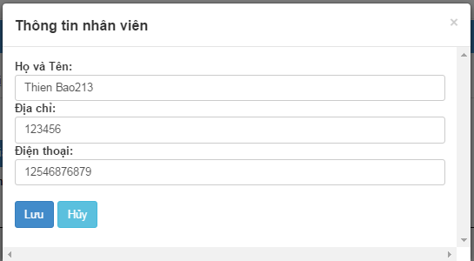

|  |  |
| --- | --- |
| Step | Instruction |
| 1. | Edit information |
| 2 | Click “Lưu” to Save changes  Click “Hủy” to return to Delivery man account management page |

#### Manage Customer account

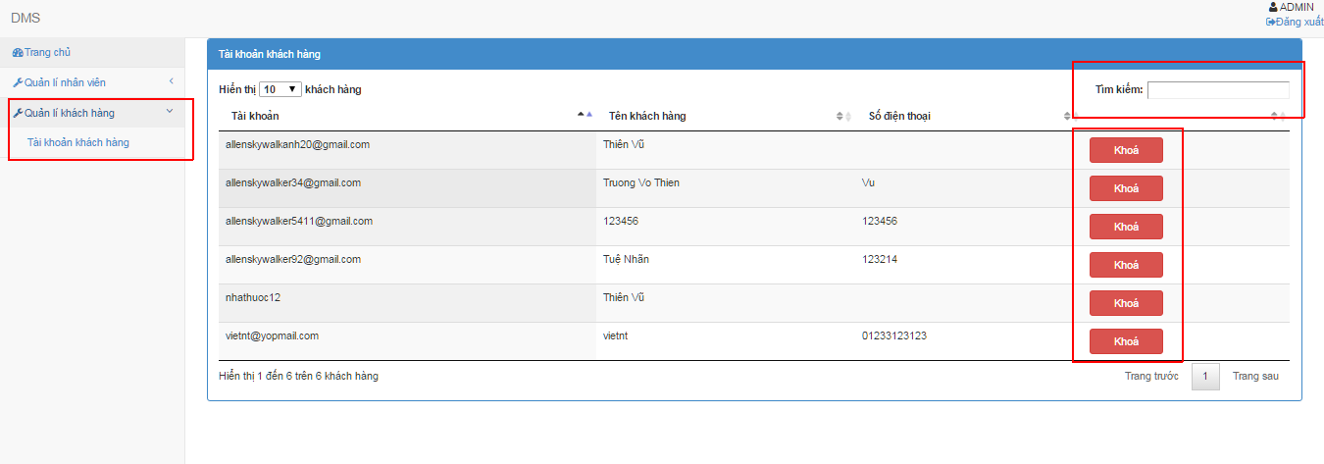

|  |  |
| --- | --- |
| Step | Instruction |
| 1. | On Administrator homepage, Click on “Quản lí khách hàng”, then click “Tài khoản khách hàng” |

##### Search Customer account

|  |  |
| --- | --- |
| Step | Instruction |
| 1. | Type in the text box “Tìm kiếm” to search for account |

##### Lock Customer account

|  |  |
| --- | --- |
| Step | Instruction |
| 1. | Click “Khóa” to lock account |